Naloxone Saves Lives

​​Starting June 1, 2017, anyone can get naloxone at a Maryland pharmacy without a prescription. To learn more click here​​

​
Naloxone (NARCAN®, EVZIO®) is a prescription medication that safely and effectively reverses an opioid overdose.

Opioid is a class of drugs that includes heroin and prescription pain relievers like oxycodone (OxyContin®, Percocet®), hydrocodone (Vicodin®, Lortab®), oxymorphone (Opana®), hydromorphone (Dilaudid®), morphine (MS Contin®), fentanyl (Duragesic®) and methadone.
​
Naloxone does NOT:
- ​Cause Addictions
- "Enable" someone's drug use or addiction
- Give the user a "high"
- Have much potential to cause harm when administered appropriately, even if the person is not actually experiencing an opioid overdose.
Doctors, paramedics, and other healthcare providers have used it for decades.
Now many more people in Maryland can get access to naloxone to save a life.

How to Get Naloxone

1. Ask your doctor – Maryland law allows any healthcare provider who can prescribe drugs in Maryland (including physicians, physician assistants,advance practice nurses, dentists and others) to prescribe naloxone. Your provider can prescribe ​you naloxone if you are personally at risk for opioid overdose OR if you are likely to witness an overdose and be in a position to respond. State law includes legal protections for you and your provider (see below).

2. Maryland Overdose Response Program –The Maryland Overdose Response Program (ORP)​​ offers in-person, hands-on training and certification in recognizing and responding to opioid overdose with naloxone. Most OR​P trainings​​ are free to attend and also provide naloxone to trainees at no charge. Visit the ORP website or cont​act the ORP​ for more information.

UPDATE: A statewide standing order​ is now in effect allowing pharmacists to dispense naloxone to ORP certificate holders without a prescription.

Pharmacies S​tocking Naloxone​​​ ​​​​(updated 12/19/2016) PDF Version​– The pharmacies on this list have been identified as currently stocking naloxone by the pharmacies’ corporate offices. Any individual may visit a participating pharmacy to get naloxone without a prescription under the statewide standing order. Individuals should ask to speak to a pharmacist about naloxone.
Naloxone Products
Naloxone can be injected into a muscle (intramuscular) or vein (intravenous) or sprayed into the nose (intranasal). Naloxone is often provided as part of a “rescue kit” that also includes:​
- ​paraphernalia for administration (nasal atomizer, syringe, needle)
- alcohol swabs
- non-latex gloves
- plastic face shield for rescue breathing
- printed materials with information on opioid overdose response and naloxone administration, overdose prevention tips and accessing addiction treatment and recovery services

There are 4 types of naloxone products available:

​ 1. For intranasal administration: 2mg/2mL single-dose Luer-Jet prefilled syringe. Include one luer-lock mucosal atomization device (MAD 300) per dose dispensed.
Directions for use:
- Spray 1 mL in each nostril.
- Repeat after 3 minutes if no or minimal response.​​​
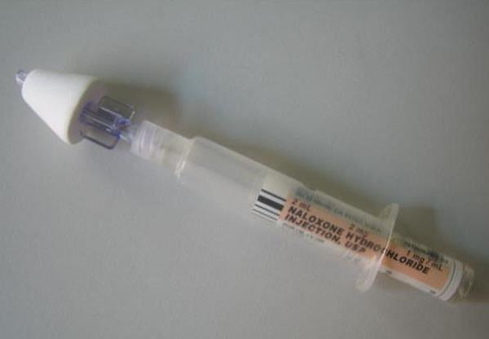
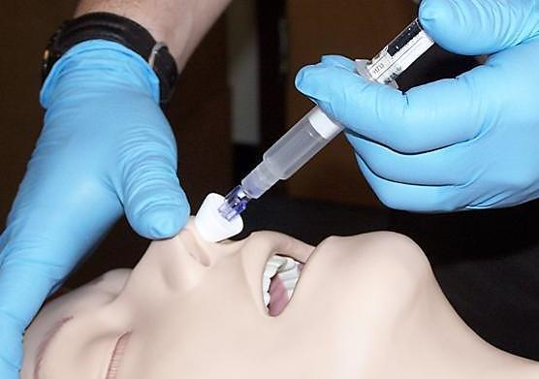
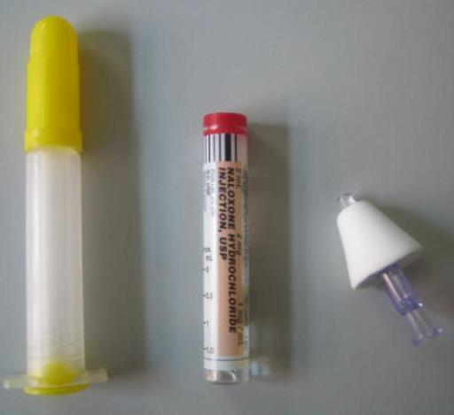
​

2. For intranasal administration: 4 mg dose
Directions for use:
- Place the tip of the nozzle in either nostril until your fingers touch the bottom of the patient’s nose.
- Press the plunger firmly to release the dose into the patient’s nose.
- Remove the device from the nostril and discard.
- Using a new device, repeat after 3 minutes if no or minimal response​

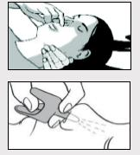
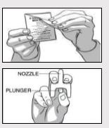
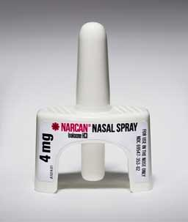

3. For intramuscular injection:​ 0.4/mL in 1mL single dose vials. Include one 3cc, 23g, 1"syringe per dose dispensed. Include face shield for rescue breathing and alcohol swabs if available.
Directions for use:
- Inject 1mL in shoulder or thigh.
- Repeat after 3 minutes if no or minimal response.
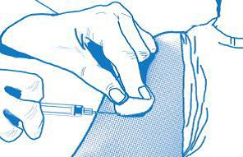
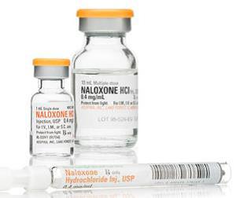

4. For intramuscular or subcutaneous injection: EVZIO® 2mg/0.4mL auto-injector, #1 Two-Pack.
Directions for use:
- Follow audio instructions from device.
- Place on thigh and inject 0.4 mL.
- Repeat after 3 minutes if no or minimal response.
